**P-vent**



**A Business Concept Presented as a Requirements for Technopreneurship**

**Joylan E. Panungcat**

**Jay-art R. Sabandal**

**Regie T. Vasquez  
Micho Basilio**

**June 2021**



**TABLE OF CONTENTS**

**CONTENT PAGE**

**Title Page**

**Project Acceptance**

**Business Logo**

**Table of Contents**

Business Statement Concept **1**

1. **Opportunity**

1.1 Pain/Need 3

1.2 Customer and Market Size 4  
 1.3 Competition 5  
 1.4 Solution and Differentiation

1.5 Competitive Advantage 5

1. Target Market  **5**

2.1 Customer Segment(s) 5

2.2 Channels to Research Market 6

2.3 Customer Relationship 6

2.4 Market Type 7

1. Productive Service **7**

3.1 Conceptual Framework 7

3.2 Main Features 7

3.3 Technology Platform 8

1. Revenue Streams **9**

4.1 Revenue Model(s) **9**

4.2 Pricing  **10**

1. **Cost Structure 10**

5.1 Cost Structure 10

5.2 Start Up Cost 11

1. Scalability **11**

6.1 Financial Production 11

6.2 Demand Potential 12

1. Founding Team 13

**APPENDICES**

**Appendix A- Product Market Fit (Know-How Entry)**

**Appendix B- Business Pitch**

**Appendix C- Minimum Viable Market**

**Appendix D- Twelve-month Cash Flow projection**

**Business Concept statement**

**P-vent** is a web application that will help people to save time to find reliable photographers for hire as well as photographers can also advertise their profile through their portfolio to attract potential clients through the use of this app. The platform allows client to discover photographers by visiting their works and advertisement. This way, they get to meet photographers with the ideal skill sets and rates who will suit their needs. Further, P-vent can be defined as an advertisement regarding to the clients who want to hire some photographers or vacancy with a company that hires well equipped and well experience photographers.

For clients, P-vent is the key to easily find photographers that suits to their needs and hence, client must find reliable photographers through visiting profiles and watching advertisement.

P-vent helps photographer to let clients know what their skills and capability by posting the sample works and captures to reach out to many clients. Posting you works on the post page will give photographer a wider potential client, a wider audience will lead to a higher probability of easily getting hire. Photographer can receive more clients if in a pro account by this it allows specific pro account giving an edge over the others.

1. **OPPORTUNITY**

* **Pain** - The growing pains of an event photography business can be intense. The problem is that building a solid reputation requires experience for photographers, but given the importance of their event, the clients aren’t risking to hire someone who is not known and has little reputation. You can see how this can be a challenging situation for the photographers.
* **Need** – P-vent will help you track and find reputable photographers. Finding photographers has become more easier through this app. It promotes an interface that makes it easy-to-use also this app allows you to enter and find photographers at your disposal to hire, and also as a photographer you can set yourself up on your availability on when and where your client need you as our app delivers a fast, reliable and secure output for the negotiation of both clients and photographers.

Slogan: “**PHOTOS THAT CAPTIVATE YOUR HEART**”.

* 1. **Customer and Market Size**

P-vent’s goal is to be successful in its duty to promote and feature photographers that are willing to serve its talent for the ones who needs it. The target customers of P-vent are the entrepreneurs and independent professional photographers.

The market size of this platform is within the area of Region XI as it comprises five provinces: Davao de Oro, Davao del Norte, Davao del Sur, Davao Oriental, and Davao Occidental. Based on the 2015 Census of Population in POPCEN 2015, as of August 1, 2015 was 4,893,318 of Region XI (Davao Region).

Furthermore, according to 2016 Annual Survey of Philippine Business and Industry (ASPBI) - Professional, Scientific and Technical Activities Sector for All Establishments: Final Results showed that a total of 7,048 establishments in formal sector of the economy were engaged in professional, scientific and technical activities. Film developing and printing and photograph enlarging followed with 827 establishments or 11 percent and Davao region is the highest percentage among 827 developing and photography establishments.

* 1. **Competition**

The competitors of this product are those group of people who create their own websites about photography event. Existing website/ application like studio ninja, VOGSY and Scoro.

* 1. **Solution**

To solve that problem, we create an application that will manage the event photography. This application allows client to learn more about the photographer and the business and check out some of the best work of photographer. To ensure the reliability of the photographer and the business. If the clients want to find a trusted and reliable photographer that are armed with all the skills, equipment, and creativity needed to capture emotions, reactions, and great memories in their important event. Also, photographer can easily get photography gig and showcase their best work, showing their beautiful shots skills.

1.4 **Competitive Advantage**

Using this application, it gives assurance to the client to find trusted and reliable photographer. Also, photographer and businesses can easily promote their works and can have more clients. It is a friendly user application and easy to use. Reasons to be convinced as P-vent is a user-friendly studio management software, it has a beautiful design, and amazing support. This is built specifically for photographers, and it is easy-to-use. Lastly, the developers care about their customers so expect implementations that can potentially improve the application.

1. **TARGET MARKET**
   1. **Customer Segment(s)**

P-vent’s customer segments were limited to entrepreneurs, freelancer, independent professional photographers at any age will be the target customer segments in this platform would be Professional Photographers, Photography Enthusiasts, iPhoneographers, Event Client and Affiliate. A professional Photographers usually used digital or film camera and also use artificial/or natural lighting to snap pictures of various people, places, variety settings and event. Photography Enthusiasts these are those photographers can be very skilled or unskilled or something in between, they usually take pictures in travel event. iPhonoeographers are those photographers taking pictures with the use iphone camera. It often refer to taking photos and immediately sending them to a photo sharing. According to 2016 Annual Survey of Philippines

* 1. **Channels to reach market**

P-vent can reach out or promote the platform through social media sites. The developers also aims to communicate in advertisement like websites, blogs and podcast. We can also communicate to the target customer through the channels of email, texts and calls.

* 1. **Customer Relationship (Get, Keep, Grow)**

GET – In order to attract potential customers, the advertisements shall be channeled through social media, and when they have the access through the app, they can register their account their emails. The account created can now use the given features by the application.

KEEP- The photos was taken by the photographers will be shown in their perspective timeline to have an updates on their works. Also, to maintain the quality service that was provided to the customers. In maintaining the customers trust and getting feedback can help the business to keep them for a long periods of time.

GROW - Increase photographer lifetime value by upselling where the application introduce more enhanced or new features that the photographer will experience in availing it through P-vent pro every month.

* 1. **Market Type**

P-vent is an existing market wherein the users, services and the competitors are known that serves the market. This application's service is available to everyone who has access to the internet.

1. 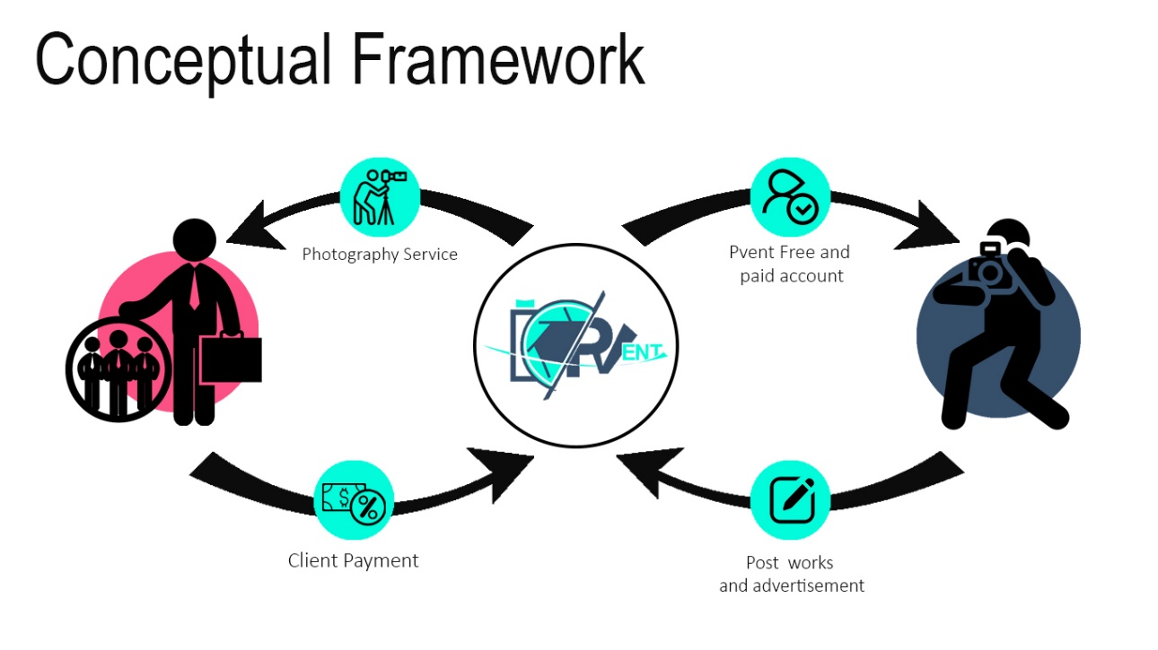**PRODUCT/SERVICE**
   1. **Conceptual Framework**

The conceptual framework shows how client and photographer can interact using the Pvent.

* 1. **Main Features**

Main feature of the platform:

* Advanced reports – allows user and photographer to customize documents like profiles, transactions, invoices and etc.
* Supports both android, ios and web based- This platform is a progressive web application that supports web and app.
* Photographer rating & feedback- allows clients to view the ratings of particular photographer.
* Photographer freelance marketplace.
* Private communication platform- this platform allows video chat and live chat.
  1. **Technology Platform**

The technology that will be using in creating this platform are:

1. Wordpress- WordPress is an open-source content management system licensed under GPLv2, which means that anyone can use or modify the WordPress software for free. A content management system is basically a tool that makes it easy to manage important aspects of your website and The end result is that WordPress makes building a website accessible to anyone.
2. Paypal - PayPal Holdings, Inc. is an American company operating an online payments system in the majority of countries that support online money transfers, and serves as an electronic alternative to traditional paper methods like checks and money orders.
3. Curity Authentication services - The Curity Authentication Service contains a whopping 25+ built-in authentication methods. This means applications can authenticate user identity by social login, SMS with Hyperlink, SMS One Time Password, Google Authenticator, BankID, and many other identity standards. Curity also provides an SDK to build your own solutions.
4. **REVENUE STREAMS**
   1. **Revenue Model(s)**

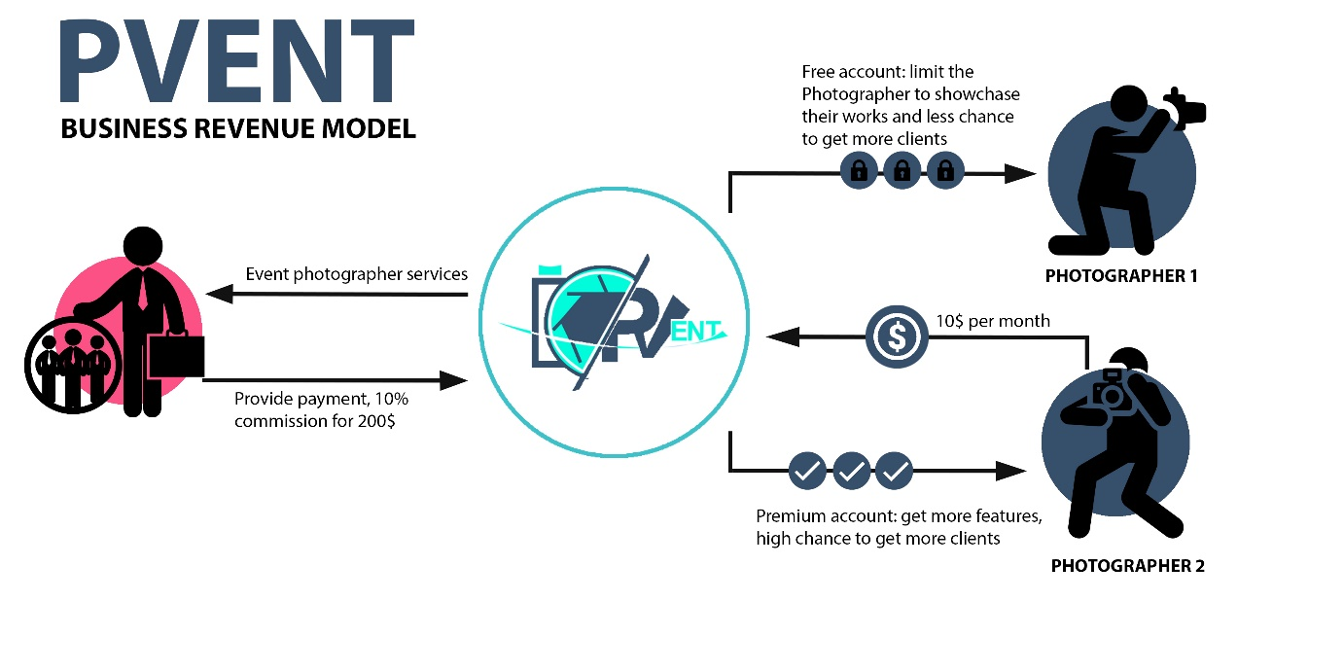

**P-vent Pro –**It is a monthly update in the application where photographers needs to pay for it to avail the new features and to experience more advance in managing their works.

**Third-party advertisement fee**- Every advertisement for their product has a fee, which changes depending on the length of the ad and the number of views it receives.

**Commision 20% over sales amount**- There is a specific percentage charge fee on every client who successfully pays the commission.

* 1. **Pricing**

The photographers will pay PHP 150 for every monthly update in the application, third- party advertisement will charge a fee according to the length and views of video. Furthermore, for every customer who will avail the service of the photographers there will be a commission fee of 20% for every PHP 10,000 from their payment.

1. **COST STRUCTURE**
   1. **Cost Areas**

To summarize the revenue, cost and expenses with the operation of the Pvent platform, the following is considered:

* Total Revenues reached up to PHP 1, 532, 3500.
* Total Fixed Assets cost reached up to PHP 188,500.
* Total Direct cost reached up to PHP 55,188.
* Total Staff Payroll cost reached up to PHP 2,580,000.
* Total Personnel Cost reached up to PHP 258,000.
* Total Sales and marketing cost reached up to PHP 240,000.
* Total Premises cost reached up to PHP 212,400
* Total Admin cost reached up to PHP 187,200.
* Total IP and Legal Cost reach up to PHP 155,500.
* Total IT/Software Development cost reached up to PHP 46,800.
* Total finance cost reached up to PHP 300,000
  1. **Startup Cost**

The startup cost could exceed PHP 500,000 and the funding members agreed to give PHP 117,000 each. Some of the funding members donate office supplies and other materials for the startup of this platform.

1. **SCALABILITY**
   1. **Financial Projection**

The Pvent Platform is expected to gain profits from every photographer who upgrade their Pvent account to Pro, the pro account fee charges PHP 150 update every month. The platform will also gain 20% for every PHP 10,000 income from the customer, based on our cash flow projection (see Appendix D), this shows the calculated total inflow PHP 1,915,000 minus the total outflows PHP 1,891,788 yearly and the total new profit result which is 23,212.

* 1. **Demand Potential**

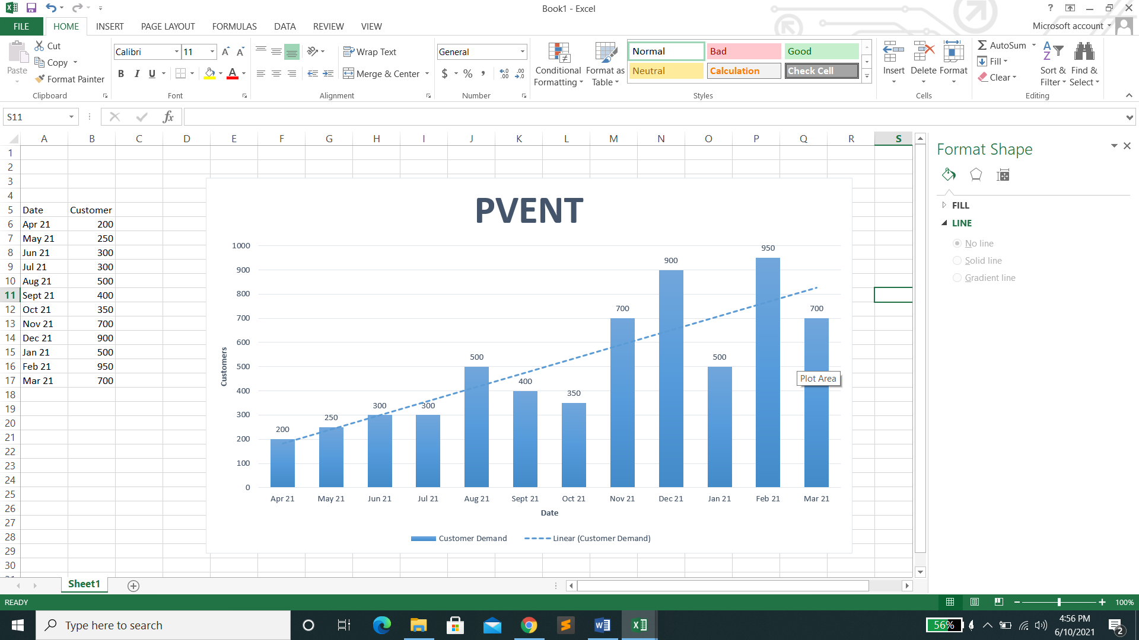The figure shows the potential demands of the target customers through the months.

1. **Founding Team**

The founding team in JJRM Company offers you a platform that will captivate your heart, easy communication and find a trusted photographer with the use of Pvent: Photography event management application will bring a clear and beautiful objectives in business industry.

**JJRM COMPANY founding team**

**Pvent**

**“PHOTOS THAT CAPTIVATE YOUR HEART”**

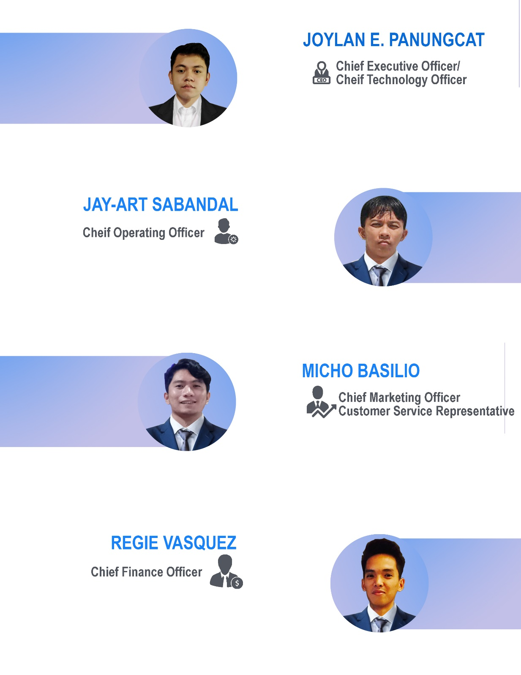

**Appendices**

**Appendix A**

**Product Market Fit**

**(Know-How Entry)**

|  |  |  |  |  |  |  |  |
| --- | --- | --- | --- | --- | --- | --- | --- |
| Contributor name(s) | Name a personal or work contact (pls list position and affiliation) | Problem description (post one row per problem if your contact mentions more than one; add new entries at the bottom of this sheet - do not insert new rows  between existing ones) | Current customer solution | Reaction to existing solutions | Other problem(s) | Name one possible innovation opportunity for this contact (E.g.  Using zzz to address the yyy that is the cause of the problem in col  E) | Link to closest existing solution (or you could cite a  KnowHow entry) |
| JOHN CARLO CALIO TANDUYAN |  | Slow Internet Connection | Companies action or service to the public (Consumers) | A poor connection to the internet is a major deterrent for us as a student, especially in this situation. | The cost of the five pesos adds extra to the fare. | Using QoS stands for Quality of Service and this router can help prioritize how much bandwidth every device gets to address the problem in slow internet connection that cause deterrent to the students. | Link to closest existing solution : Slow Connection – Solutions to speed up the Internet.(n.d).citypassenger.https://www.citypassenger.com/en/solutionsto-speed-up-the-internet/.retrieved April 06, 2021 |
| Brian Diokno Maravillas | Student/Davao del Norte State College/BSIT | slow connection | make the connection more faster | a litle bit exhausted | time and deadlines of activities and my job | Using QoS stands for Quality of Service and this router can help prioritize how much bandwidth every device gets to address the problem in slow internet connection that cause of feeling a little bit exhausted. | Link to closest existing solution : Slow Connection – Solutions to speed up the Internet.(n.d).citypassenger.https://www.citypassenger.com/en/solutionsto-speed-up-the-internet/.retrieved April 06, 2021 |
| John Rolan Pama | Student/Davao del Norte State College/BSIT | Now online modular very worse situation for me as a student | Enhanced enternet connection | Anger sometimes | Very slow working electronic devices | Using the educational apps to address the problem in online modular that cause of being anger sometimes to work in school activities. | Link to the closest existing solution: 9 Essential Apps to Help You Survive  Your Online Classes.(n.d)Colorado State  University.https://blog.online.colostate.edu/blog/education/9-essential-apps-tohelp-you-survive-your-online-classes/. Retrieved. April 6, 2021 |
| Jun -evon Villejo | Employee/Virginia Company/Merchandiser | transportation | fast transportation | I feel disappointed sometimes | Internet Connection | Using the mobile application like uber and corb to address the problem in transportation that cause of feeling disappoindted. | Link to the closest existing solution: 10 best transit apps and transportation apps for Android!.(n.d).Android  Authority.https://www.androidauthority.com/best-transit-apps-android-782796/. Retrived. April 6, 2021 |
| Kenneth John Macuto Intas | Student/KorphilDavao/BSIT | Poor cellphone capacity | Limit playing games | Sadness of course because i can't play games everytime i want | Limited amount of Mobile data | Using the mobile application to boosten your experience in your phone device to adress the problem in slow devices/ technology that cause of being sad that you cant play games that you wanted to play | Link to the closest existing solution: 8 apps to improve your android phone performance.(n.d).Turbo Future.https://turbofuture.com/cell-phones/6-AndroidApps-to-Improve-Phone-Performance. Retrive. April 6. 2021 |
| John Gerber P. Ungcad | Student/Davao del Norte State College/BSIT | Slow Devices | Uninstall some application | I feel disappointed sometimes | None | Using the mobile application to boosten your experience in your phone device to address the problem in slow devices/ technology that cause of being disappointed sometime. | Link to the closest existing solution: 8 apps to improve your android phone performance.(n.d).Turbo Future.https://turbofuture.com/cell-phones/6-AndroidApps-to-Improve-Phone-Performance. Retrive. April 6. 2021 |
| Hennie Joyce Ellera | Student/University of Southeastern Philippines /Bachelor of Science in Entrepreneurship | Online class because in our place it's always having a weak signal. | Find a piso wifi vendo so that I can easily enter the class. | I feel pissed yet happy at the same time since I always find a solution to that certain problem. | Typing documents in cellphone. | Using the educational apps to address the problem in online modular to feel good and determined to work in school task/ activities. |  |
| LYZA MAE BALON. MANGIN | Student/Davao del Norte State College/BSIT  Student/Holy Cross of Davao College/Bachelor of Science in | Slow internet connection | I buy more big data | Expensive | Laptop don't work sometimes | Using QoS stands for Quality of Service and this router can help prioritize how much bandwidth every device gets to address the problem in slow internet connection to feel satisfied by doing school task. | Link to closest existing solution : Slow Connection – Solutions to speed up the Internet.(n.d).citypassenger.https://www.citypassenger.com/en/solutionsto-speed-up-the-internet/.retrieved April 06, 2021 |
| Monica May Barrera | Accountancy | Being procrastinate in doing school works because of technology | I don't yet find any solution about it | I don't know | Internet Connection |  |  |
| Ellera, Jhea Mae | Student/Assumption College/HUMSS | Weak connection, and signal | I sometimes go to Piso Wifi Vendo, and it helps me to cover up my problem of not having a good signal. | Irritated but glad also | None | Using QoS stands for Quality of Service and this router can help prioritize how much bandwidth every device gets to address the problem in slow internet connection to feel satisfied by doing school task. | Link to closest existing solution : Slow Connection – Solutions to speed up the Internet.(n.d).citypassenger.https://www.citypassenger.com/en/solutionsto-speed-up-the-internet/.retrieved April 06, 2021 |
| Angelica P. Garcia | School/University of Mindanao/BS in Criminology | Technology, Financial, Internet Connection | In the meantime, I started a small business to provide for myself. Also, I use my old computer to attend my online classes. Though it's often lag I'm just enduring it so I could still attend classes everyday. Lastly, for my internet connection, I use mobile data because the PISO WiFi that I used before has so many users that it became so slow. Somehow, although the mobile data is not fast, it was better than the PISO WiFi. | I'm not quite satisfied but it was the best choice I for now. Maybe, when things becomes better, I'll improve those solutions of mine in order to lessen my suffering. | Academic Pressure | Using QoS stands for Quality of Service and this router can help prioritize how much bandwidth every device gets to address the problem in slow internet connection to feel satisfied by doing school task. | Link to closest existing solution : Slow Connection – Solutions to speed up the Internet.(n.d).citypassenger.https://www.citypassenger.com/en/solutionsto-speed-up-the-internet/.retrieved April 06, 2021 |
| Ma. Bernizelle Amores Silawan | Student/University of Southeastern Philippines/Bachelor of Science in Hospitality Management | Slow Internet | buy load for mobile data | I'm confused. | None | Using QoS stands for Quality of Service and this router can help prioritize how much bandwidth every device gets to address the problem in slow internet connection that cause of being confused . | Link to closest existing solution : Slow Connection – Solutions to speed up the Internet.(n.d).citypassenger.https://www.citypassenger.com/en/solutionsto-speed-up-the-internet/.retrieved April 06, 2021 |
| Charish Lobaton Cosino | Student/Elpidio Quirino High School/HUMMS | Slow Internet | Do all the activities on when it is given to avoid cramming. | Anger sometimes | Emotion and Anxiety problems | Using QoS stands for Quality of Service and this router can help prioritize how much bandwidth every device gets to address the problem in slow internet connection to feel satisfied by doing school task. | Link to closest existing solution : Slow Connection – Solutions to speed up the Internet.(n.d).citypassenger.https://www.citypassenger.com/en/solutionsto-speed-up-the-internet/.retrieved April 06, 2021 |
| JAY ART RUELAN SABANDAL | Student/Davao del Norte State College/BSIT | The very slow and very low internet connections. Especially the network connections, it is very hard to use because the data connection is too slow. | Long of patience. | I will accept the fact that in the Philippines our country have a very slow and a very low internet connections and even data connections in each different networks. | None | Using QoS stands for Quality of Service and this router can help prioritize how much bandwidth every device gets to address the problem in slow internet connection to feel satisfied by doing school task. | Link to closest existing solution : Slow Connection – Solutions to speed up the Internet.(n.d).citypassenger.https://www.citypassenger.com/en/solutionsto-speed-up-the-internet/.retrieved April 06, 2021 |
| Jayson Ligue Lozada | Student/University of Southeastern Philippines /BSHM- Hotel  Administration | transportation | nothing | nothing | nothing | Using the mobile application like uber and corb to address the problem in transportation that cause of feeling disappoindted. | Link to the closest existing solution: 10 best transit apps and transportation apps for Android!.(n.d).Android  Authority.https://www.androidauthority.com/best-transit-apps-android-782796/. Retrived. April 6, 2021 |
| Christian Vince Calma Alce | Student/University of Southeastern Philippines /BSHM | weak connection, hectic schedule of balancing schoolworks and house chores | buying load, looking for better signal reception and time management | it surprisingly good so far | it surprisingly good so far | Using QoS stands for Quality of Service and this router can help prioritize how much bandwidth every device gets to address the problem in slow internet connection to feel satisfied by doing school task. | Link to closest existing solution : Slow Connection – Solutions to speed up the Internet.(n.d).citypassenger.https://www.citypassenger.com/en/solutionsto-speed-up-the-internet/.retrieved April 06, 2021 |
| Princess Mae Bondame Ababat | Student/University of Southeastern Philippines/Bachelor of  Science in Hospitality Management | Technology - low internet connection/bigger mobile data | weekly load/ call internet service provider | It somehow solve issues with my internet connection | error loading of websites | Using QoS stands for Quality of Service and this router can help prioritize how much bandwidth every device gets to address the problem in slow internet connection to feel satisfied by doing school task. | Link to closest existing solution : Slow Connection – Solutions to speed up the Internet.(n.d).citypassenger.https://www.citypassenger.com/en/solutionsto-speed-up-the-internet/.retrieved April 06, 2021 |
| Bico, Ericka Jay C. | Student/USeP - College of Business Administration/BSHM | The internet connection | Use Piso wifi instead of using prepaid load. | It is less hassle and more convenient. | Loud noises | Using QoS stands for Quality of Service and this router can help prioritize how much bandwidth every device gets to address the problem in slow internet connection that cause of hassle and not more convenient | Link to closest existing solution : Slow Connection – Solutions to speed up the Internet.(n.d).citypassenger.https://www.citypassenger.com/en/solutionsto-speed-up-the-internet/.retrieved April 06, 2021 |
| Leah Mae M. Tagalog | Student/Holy Cross of Davao College/BSBA-HRM | Slow/Lost internet connection | High speed of internet connection at a low or affordable price. | Government must provide or find a fast/high speed of internet connection company wherein it consider the capacity of every people to pay in an affordable price. | Financial Problem/ Lost of work (parents) | Using QoS stands for Quality of Service and this router can help prioritize how much bandwidth every device gets to address the problem in slow internet connection to feel satisfied by doing school task. | Link to closest existing solution : Slow Connection – Solutions to speed up the Internet.(n.d).citypassenger.https://www.citypassenger.com/en/solutionsto-speed-up-the-internet/.retrieved April 06, 2021 |
| 6 | Student/University of Southeastern Philippines/BS Hospitality Management | Poor Internet connection | Go to the near piso wifi | Satisfied | Durability of my mobile phone | Using QoS stands for Quality of Service and this router can help prioritize how much bandwidth every device gets to address the problem in slow internet connection to feel satisfied by doing school task. | Link to closest existing solution : Slow Connection – Solutions to speed up the Internet.(n.d).citypassenger.https://www.citypassenger.com/en/solutionsto-speed-up-the-internet/.retrieved April 06, 2021 |
| Rane Albarico Obañana | Student/Holy Cross of Davao College, Inc./BS in Real Estate Management | transportation allowance | saving money and don't buy unnecessary things | thankful that it's effective | monthly expenses esp. for my apartment | Using the mobile application like uber and corb to address the problem in transportation that cause of feeling disappoindted. | Link to the closest existing solution: 10 best transit apps and transportation apps for Android!.(n.d).Android  Authority.https://www.androidauthority.com/best-transit-apps-android-782796/. Retrived. April 6, 2021 |
| Joefrey Caral Yanson | Student/University of Mindanao/BACHELOR OF SCIENCE IN  COMPUTER SCIENCE | Transportation, Load, Money. | Be early to not be late. Save money to buy load. Work to gain money.a | Its good because it keep improving on how will the problem become more easy to be done as the pain of individual ease. | FAMILY AND FINANCIAL PROBLEM. | Using the mobile application like uber and corb to address the problem in transportation that cause of feeling disappoindted. | Link to the closest existing solution: 10 best transit apps and transportation apps for Android!.(n.d).Android  Authority.https://www.androidauthority.com/best-transit-apps-android-782796/. Retrived. April 6, 2021 |
| Mary Rose Yu Garcia | Student/San Pedro College/BS Psychology | Slow internet connection | Back it up with internet data | My solution does not really solve my main problem, and does not also help most of the times. | None | Using QoS stands for Quality of Service and this router can help prioritize how much bandwidth every device gets to address the problem in slow internet connection to feel satisfied by doing school task. | Link to closest existing solution : Slow Connection – Solutions to speed up the Internet.(n.d).citypassenger.https://www.citypassenger.com/en/solutionsto-speed-up-the-internet/.retrieved April 06, 2021 |
| Allyssa Mae Sibug Paz | Orani National High School Parang-Parang/Academic Track, Humanities and Social Sciences | Transportation | Walk instead of waiting for transportation | Sad maybe? We need to walk which is hassle for us also time consuming. | None | Using the mobile application like uber and corb to address the problem in transportation that cause of feeling disappoindted. | Link to the closest existing solution: 10 best transit apps and transportation apps for Android!.(n.d).Android  Authority.https://www.androidauthority.com/best-transit-apps-android-782796/. Retrived. April 6, 2021 |
| Angel Rein Mae Nollora Rosales | Student/Assumption College of Davao/HUMSS | Technology, it's too slow for me to manage ang I don't have a lot of patience about it. | Restarting the device or cleaning it so that I will be able to use it again that is much better before i restart or clean the device. | I am satisfied on what I am doing to solve my problem. | Connection Problem, Financial Problem | Using the mobile application to boosten your experience in your phone device to address the problem in slow devices/ technology that cause of being disappointed sometime. | Link to the closest existing solution: 8 apps to improve your android phone performance.(n.d).Turbo Future.https://turbofuture.com/cell-phones/6-AndroidApps-to-Improve-Phone-Performance. Retrive. April 6. 2021 |
| CLARK LAWRENCE J. MARTINEZ | Student/JOSE RIZAL UNIVERSITY/SHS-ABM | TECHNOLOGY | improving internet conection | Bothered | Transportation | Using the mobile application to boosten your experience in your phone device to address the problem in slow devices/ technology that cause of being disappointed sometime. | Link to the closest existing solution: 8 apps to improve your android phone performance.(n.d).Turbo Future.https://turbofuture.com/cell-phones/6-AndroidApps-to-Improve-Phone-Performance. Retrive. April 6. 2021 |

|  |  |  |  |  |  |  |  |
| --- | --- | --- | --- | --- | --- | --- | --- |
| Jhon Vincent, R, Yaun | Student/Assumption College of Davao/Humanities and Social Sciences | Poor Internet Connection and Heavy Traffic | Switch the source of my internet into more faster and commute early to avoid heavy traffic. | I'm happy and satisfied. | Procrastination and Time management | Using QoS stands for Quality of Service and this router can help prioritize how much bandwidth every device gets to address the problem in slow internet connection to feel satisfied by doing school task. | Link to closest existing solution : Slow Connection – Solutions to speed up the Internet.(n.d).citypassenger.https://www.citypassenger.com/en/solutionsto-speed-up-the-internet/.retrieved April 06, 2021 |
| Lyle Jan Ayuban | Student/Assumption College of Davao/HUMMS | Slow Internet Connection | Do your task as soon as possible | Unsatisfied | None | Using QoS stands for Quality of Service and this router can help prioritize how much bandwidth every device gets to address the problem in slow internet connection to feel satisfied by doing school task. | Link to closest existing solution : Slow Connection – Solutions to speed up the Internet.(n.d).citypassenger.https://www.citypassenger.com/en/solutionsto-speed-up-the-internet/.retrieved April 06, 2021 |
| Gabrielle G. Delica | Student./University of Rizal System- Cainta Campus/Bachelor of Secondary Education major in English | Slow internnet | I am having a patience and virtue in doing my stuff with internet. | Anger sometimes | Problems in family, myself, and othe life issues | Using QoS stands for Quality of Service and this router can help prioritize how much bandwidth every device gets to address the problem in slow internet connection to feel anger by doing school task. | Link to closest existing solution : Slow Connection – Solutions to speed up the Internet.(n.d).citypassenger.https://www.citypassenger.com/en/solutionsto-speed-up-the-internet/.retrieved April 06, 2021 |
| MONICA YSABELLE FLORES | Student/Ramon Magsaysay Highschool España Manila/HUMSS | Stress and pressure about school | Time management | Feel pressure | Academic Pressure | Using the educational apps to address the problem in online modular that cause of being pressure to work in school activities. | Link to the closest existing solution: 9 Essential Apps to Help You Survive  Your Online Classes.(n.d)Colorado State  University.https://blog.online.colostate.edu/blog/education/9-essential-apps-tohelp-you-survive-your-online-classes/. Retrieved. April 6, 2021 |
| Angela Bea Tutor Laranang | Student/Francisco Bustamante National High School/ABM | School activies | Time management | I feel unsatisfied in online learning | None | Using the educational apps to address the problem in online modular that cause of being unsatisfied of the learning in online school | Link to the closest existing solution: 9 Essential Apps to Help You Survive  Your Online Classes.(n.d)Colorado State  University.https://blog.online.colostate.edu/blog/education/9-essential-apps-tohelp-you-survive-your-online-classes/. Retrieved. April 6, 2021 |
| Marianne R. Espoltero | Student/Assumption College of Davao/HUMSS | experiencing lags in my phone and laptop | delete some unused or extra files to clean up my storage for smoother use | unsatisfied | None | Using the mobile application to boosten your experience in your phone device to address the problem in slow devices/ technology that cause of being unsatisfied | Link to the closest existing solution: 8 apps to improve your android phone performance.(n.d).Turbo Future.https://turbofuture.com/cell-phones/6-AndroidApps-to-Improve-Phone-Performance. Retrive. April 6. 2021 |
| Izzy Catubigan Membreve | Student/University of Mindanao Ilang Highschool/HUMSS | Internet Connection | Load | Relief | None | Using QoS stands for Quality of Service and this router can help prioritize how much bandwidth every device gets to address the problem in slow internet connection to feel relief by doing school task. | Link to closest existing solution : Slow Connection – Solutions to speed up the Internet.(n.d).citypassenger.https://www.citypassenger.com/en/solutionsto-speed-up-the-internet/.retrieved April 06, 2021 |
| Russel Alto, Dar Juan | Student/Bestlink college of the  philippines/BACHELOR OF SCIENCE IN  HOSPITALITY AND MANAGEMENT | Slow technology | Limit the time in using devices | Feel pressure and angry sometimes | None | Using the mobile application to boosten your experience in your phone device to address the problem in slow devices/ technology that cause of being pressure and angry sometimes. | Link to the closest existing solution: 8 apps to improve your android phone performance.(n.d).Turbo Future.https://turbofuture.com/cell-phones/6-AndroidApps-to-Improve-Phone-Performance. Retrive. April 6. 2021 |
| Alyzza Ampuyas Tuazon | Student/Philippine Christian University/ABM | Family problem (Financial), Anxiety,internet connection | Pray and time management | sad | School Activities | Using QoS stands for Quality of Service and this router can help prioritize how much bandwidth every device gets to address the problem in slow internet connection to feel satisfied by doing school task. | Link to closest existing solution : Slow Connection – Solutions to speed up the Internet.(n.d).citypassenger.https://www.citypassenger.com/en/solutionsto-speed-up-the-internet/.retrieved April 06, 2021 |
| Carl John Damaso Buctuab | Student./University of Southeastern  Philippines/Bachelor of Arts Literature in Cultural  Studies | Transportation and gadgets for communication | I sometimes borrowed gadgets from my uncles, | I feel a little not comfort and contented as of now | Time management, and self discipline | Using the mobile application like uber and corb to address the problem in transportation that cause of feeling of being not comfortale and contented. | Link to the closest existing solution: 10 best transit apps and transportation apps for Android!.(n.d).Android  Authority.https://www.androidauthority.com/best-transit-apps-android-782796/. Retrived. April 6, 2021 |
| Abel Glenn O. Dael | School/University of Southeastern Philippines/BS Entrepreneurship | small number of transportation | bicycle | not satisfied | slow internet | Using the mobile application like uber and corb to address the problem in transportation that cause of feeling not satisfied | Link to the closest existing solution: 10 best transit apps and transportation apps for Android!.(n.d).Android  Authority.https://www.androidauthority.com/best-transit-apps-android-782796/. Retrived. April 6, 2021 |
| Dimple Quimada Dutosme | Student/F.Bangoy National High School (Senior High School)/HUMSS | tansportation | Time Management and Be Motivated to do a work everyday | Im hesitant but I hope I can do it. | None | Using the mobile application like uber and corb to address the problem in transportation that cause of feeling of being not comfortale and contented. | Link to the closest existing solution: 10 best transit apps and transportation apps for Android!.(n.d).Android  Authority.https://www.androidauthority.com/best-transit-apps-android-782796/. Retrived. April 6, 2021 |
| Krizzia Myka D. Pelingon | Student/Assumption College of Davao/Humss | those problems are the Internet connection or the technology. | For me the current solution is being patient. | I was struggling and also unhappy with that problems. | financial problem, family problem | Using QoS stands for Quality of Service and this router can help prioritize how much bandwidth every device gets to address the problem in slow internet connection that cause of stuggling and also unhappy. | Link to closest existing solution : Slow Connection – Solutions to speed up the Internet.(n.d).citypassenger.https://www.citypassenger.com/en/solutionsto-speed-up-the-internet/.retrieved April 06, 2021 |
| Trisha Anne T. Chua | Student/MMMSS | Low internet connection | Off wifi in other devices | Disappointed | None | Using QoS stands for Quality of Service and this router can help prioritize how much bandwidth every device gets to address the problem in slow internet connection to feel satisfied by doing school task. | Link to clesest existing solution : Slow Connection – Solutions to speed up the Internet.(n.d).citypassenger.https://www.citypassenger.com/en/solutionsto-speed-up-the-internet/.retrieved April 06, 2021 |

**Appendix B**

**Business Pitch**

**BUSINESS PITCH**

Hi! We are the JJRM company, the founder and co-founders of P-vent.

Do you follow what your heart desire is? Do you love documenting moments in time? By taking pictures and share them with others, you're displaying a moment that has been frozen in a moment. From the atmosphere to what individuals are doing, this snapshot may reveal a lot.

The events of a person's life provide a good ground for creating a remarkable memoir. We use cameras almost every day to capture what we are doing and help us reminisce those moments that are passing by. These technologies are essential to society in many ways, just like documenting the best moment of their life.

An event photography business's growing pains can be unpleasant. The issue is that creating an excellent reputation for photographers involves expertise. Still, given the importance of their event, clients will not risk hiring someone who is unknown and has a poor reputation. It's easy to understand how this may be a problematic scenario for the photographers.

A web application platform like P-vent helps aspiring photographers appreciate their works and hire them to be part of the most memorable events of an individual. Through this web application, clients will be able to save time while looking for trustworthy photographers for hire. In contrast, photographers will display their profiles through their portfolios to attract new clients and post their capabilities like sample works to reach out in the client's hearts.

P-vent can be an advertisement for clients looking to employ photographers or a job opening with a firm that recruits well-equipped and experienced photographers. Here at JJRM Company and P-vent, we will help you follow your heart's desire and photos that captivate an individual's heart.

**Appendix C**

**Minimum Viable Product**



**Figure 1. Homepage**

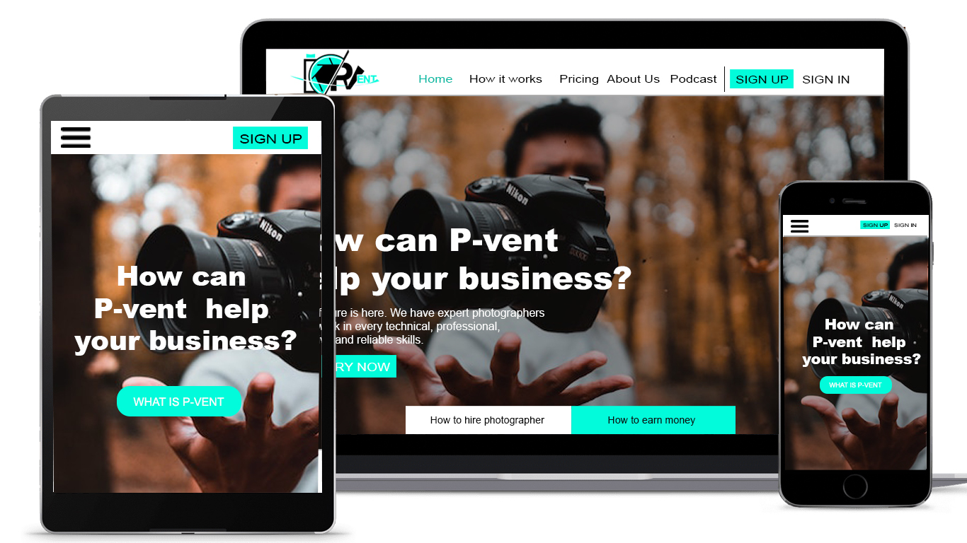

**Figure 2. How it works**

**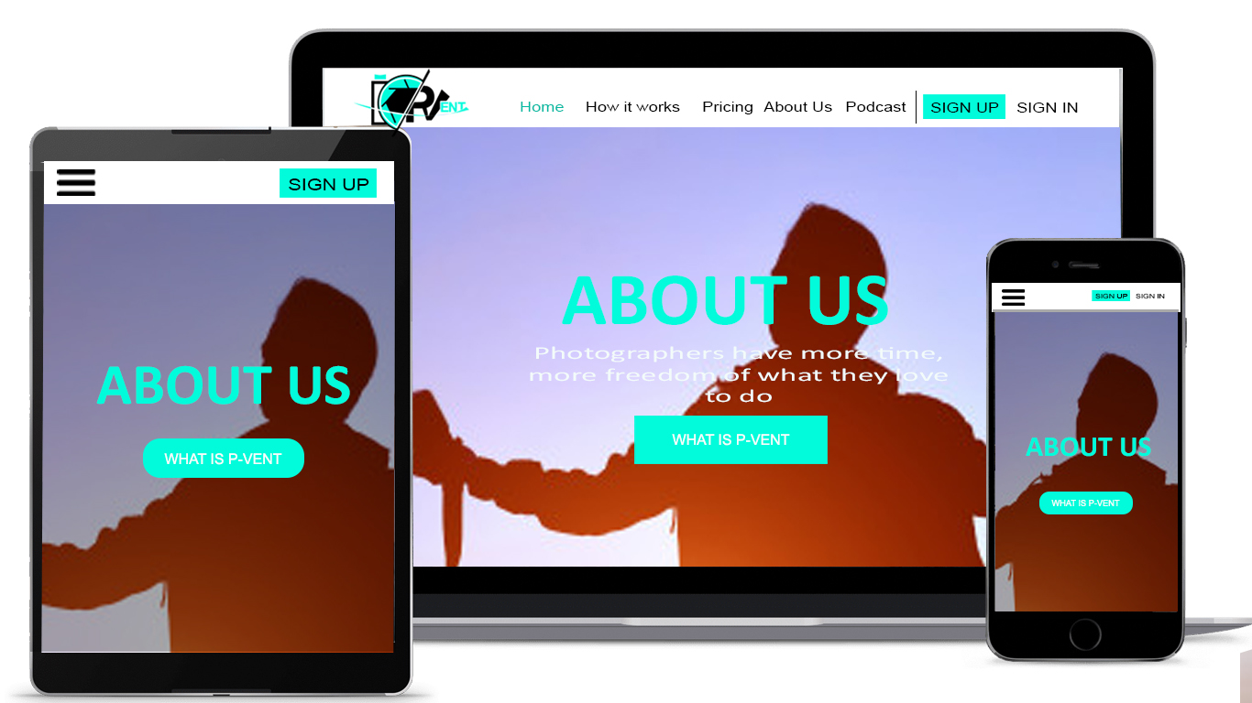  
Figure 3. About us**

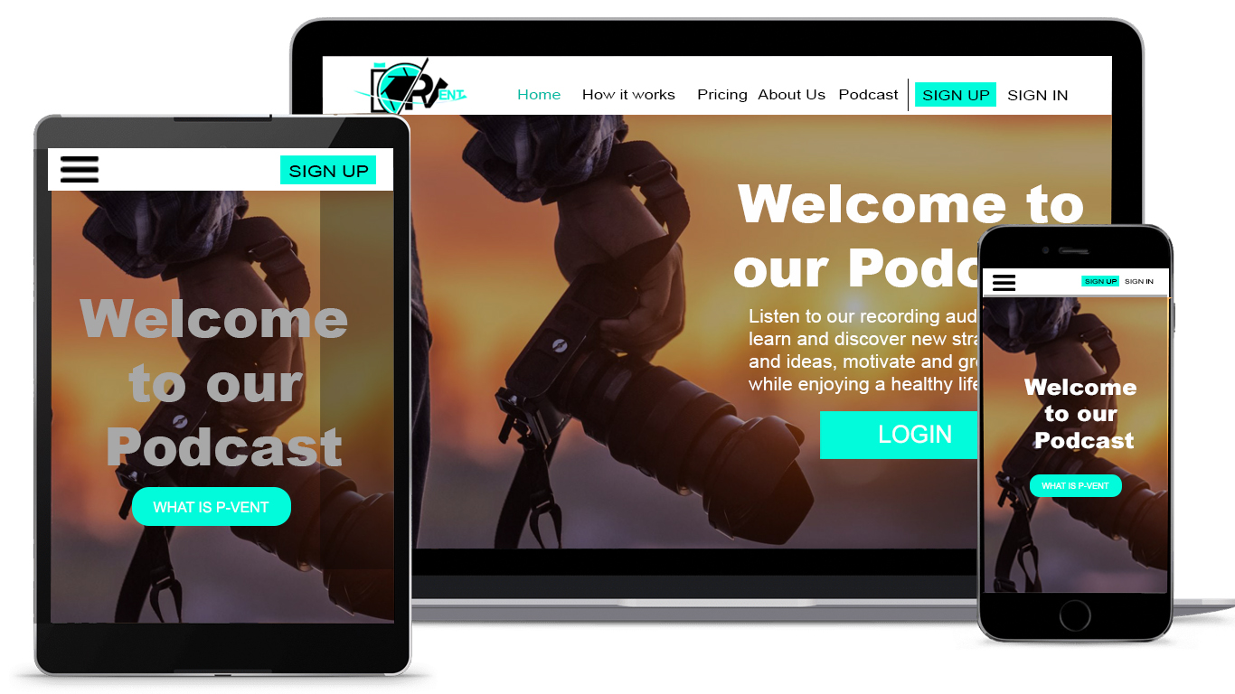

**Figure 4. Podcast**

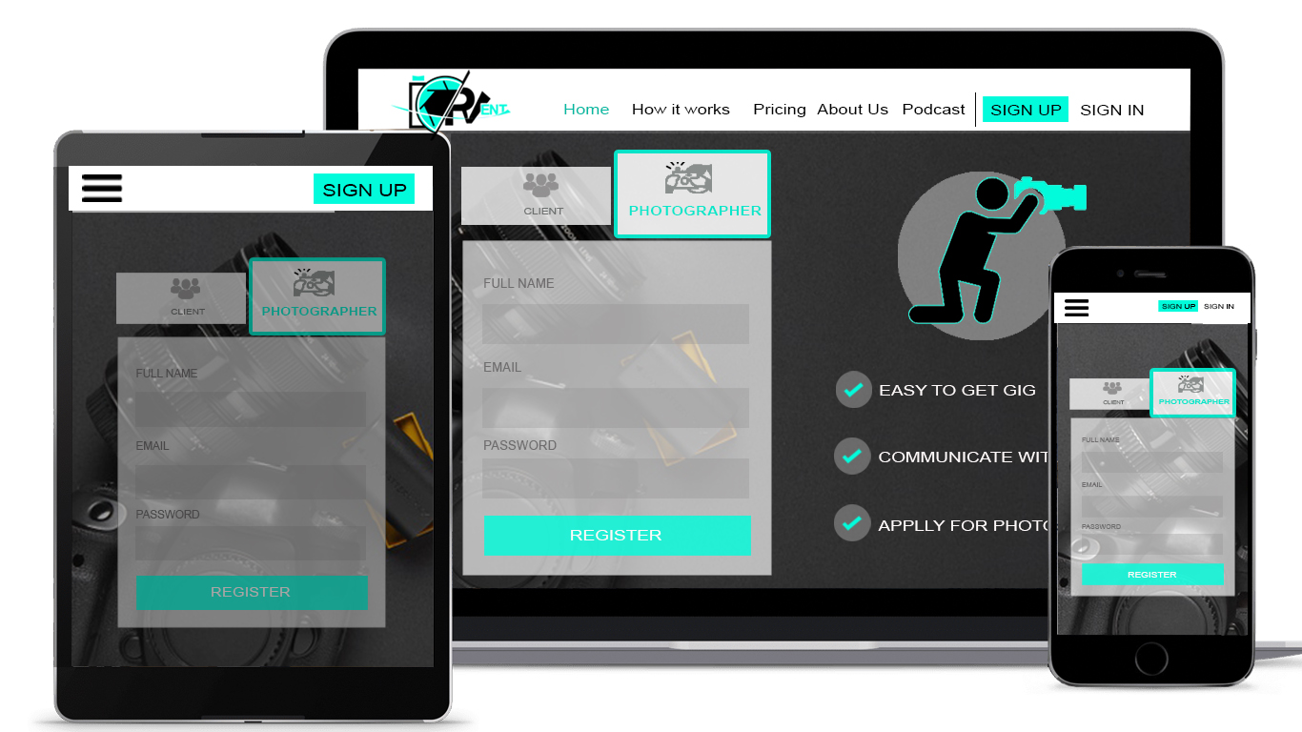

**Figure 5. Client Signup**

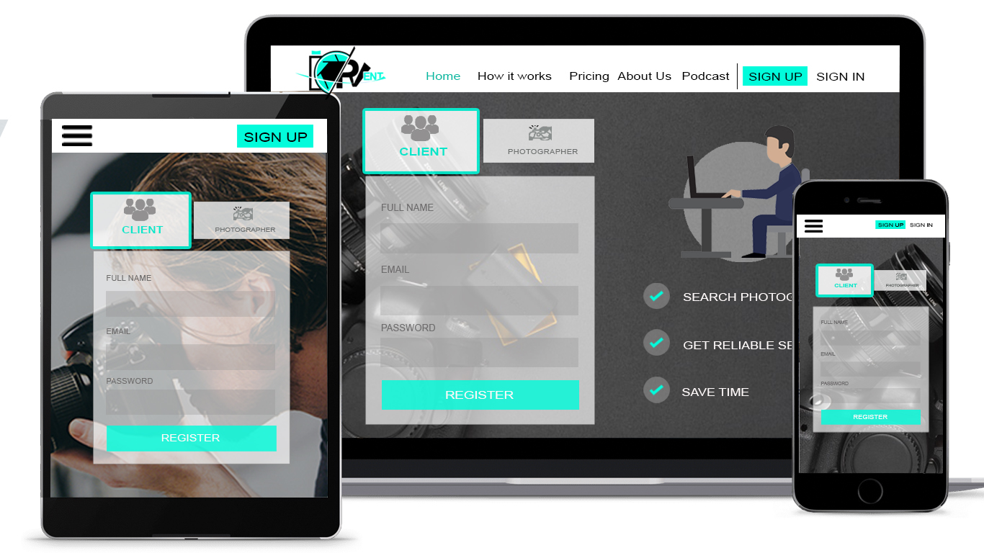

**Figure 6. Photographer Signup**

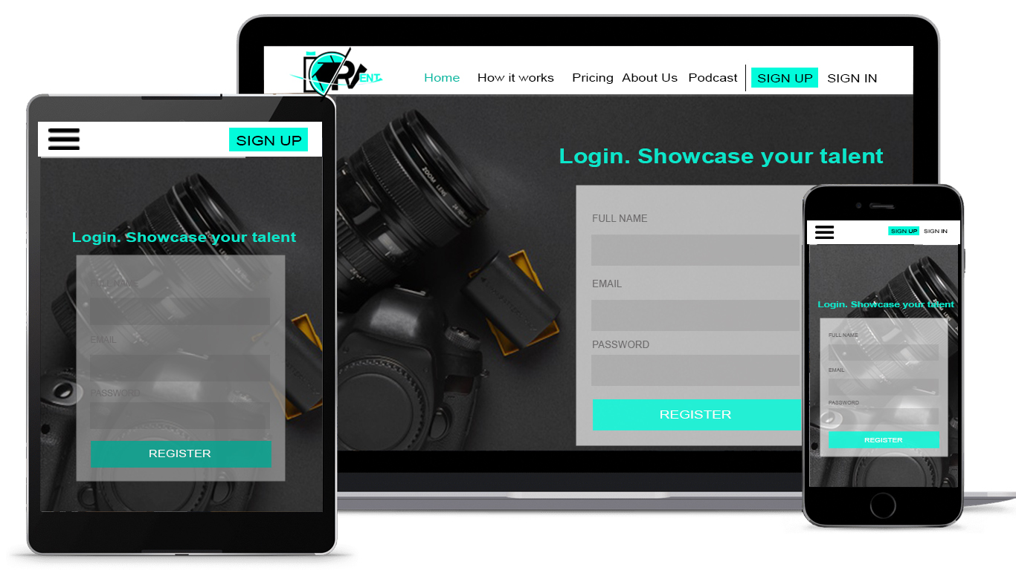

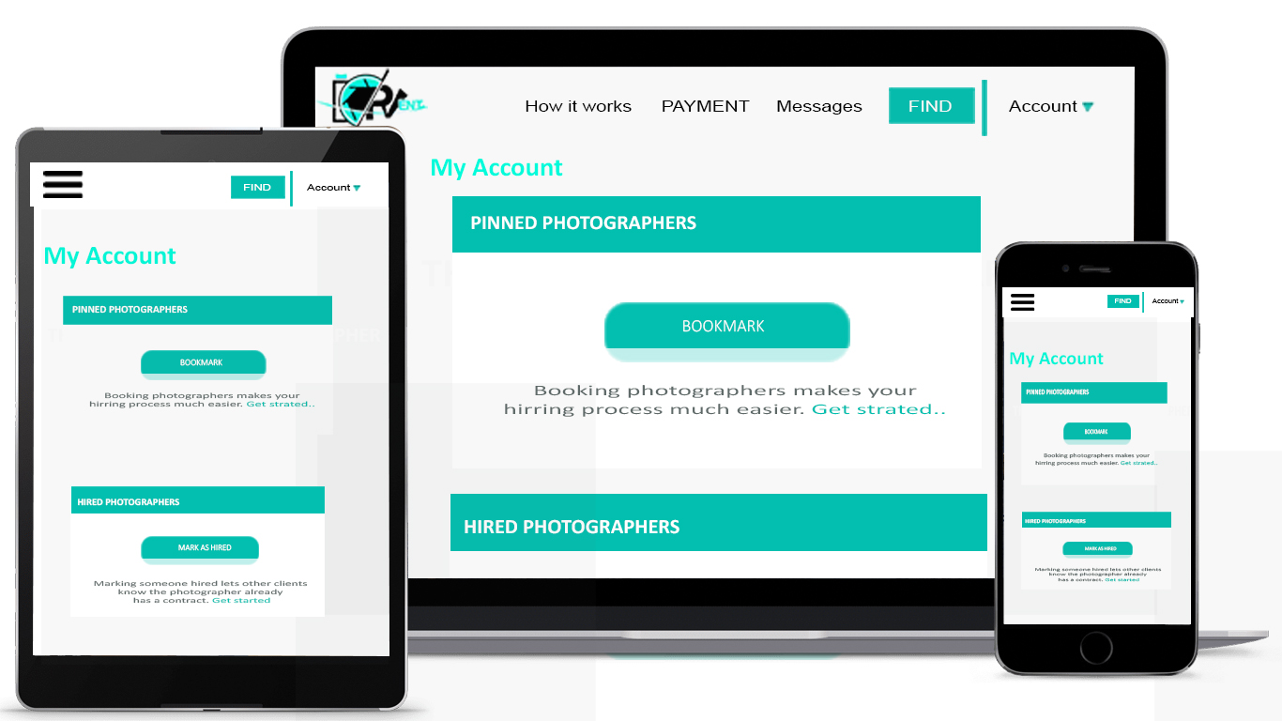**Figure 7. Login Form  
  
  
  
  
  
  
  
  
  
  
  
  
  
  
  
Figure 8. Clients Profile**

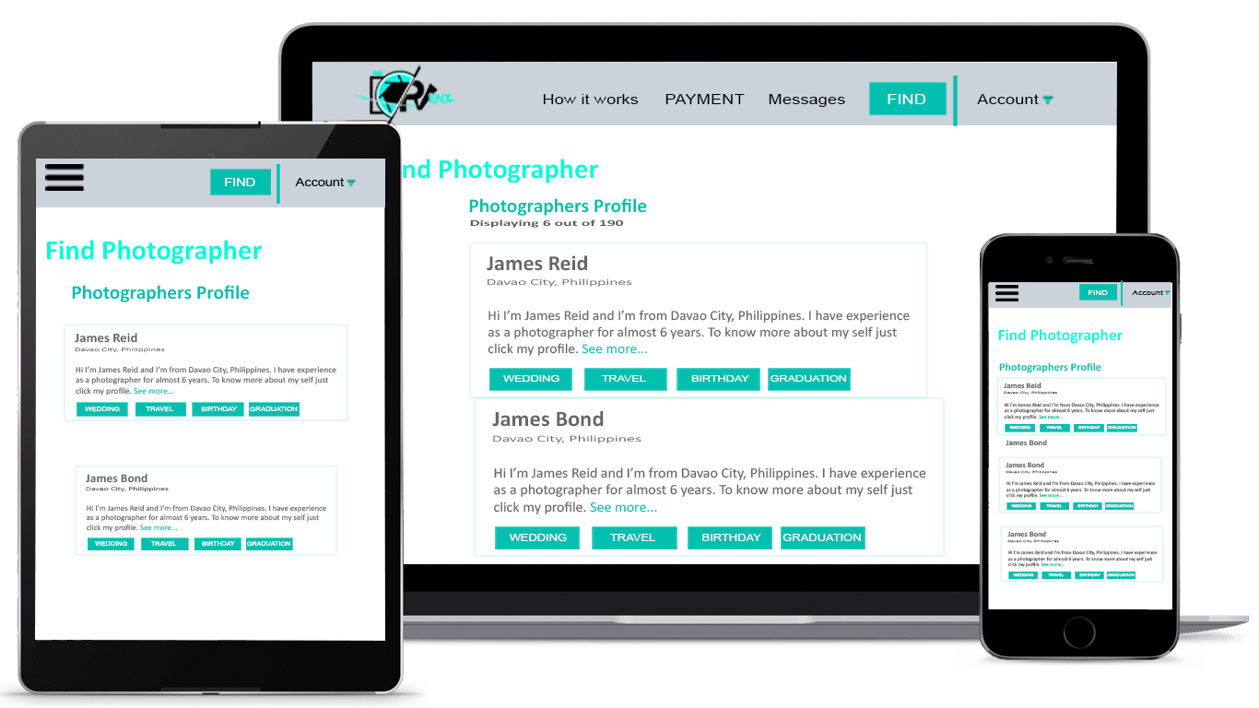

**Figure 9. Clients find photographer**

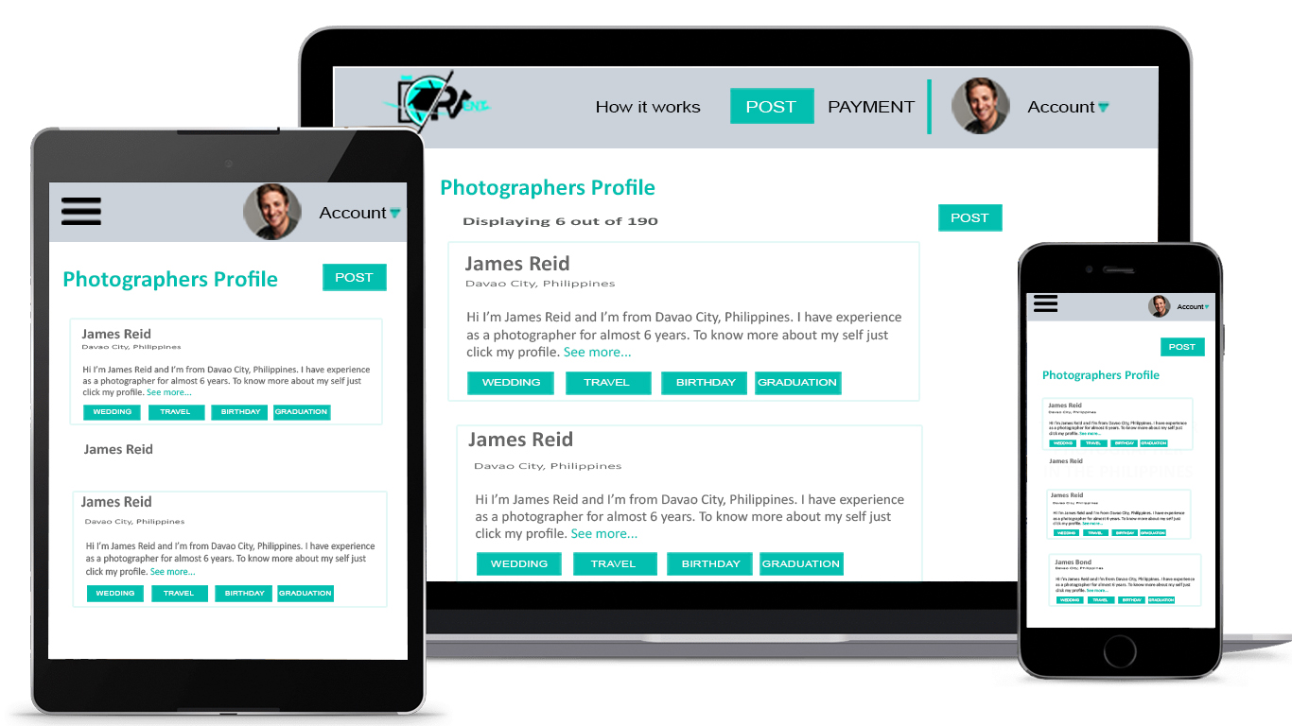

**Figure 10. Photographers Profile**



**Figure 11. Post Photographers Profile**

**Appendix D**

**Twelve-Month Cash**

**Flow**

